**IFT 166: Introduction to Internet Networking**

**Lab 27**

**Network Management with ipMonitor**

**Part 1: Install ipMonitor**

1. ipMonitor is a free network monitoring software which identifies SNMP agents on a network. Click the link to go to the download page, register and install the software: <https://www.solarwinds.com/free-tools/ipmonitor-free/registration>
2. Click next through the first Run Service Settings
3. Click next through the first Run HTTP Server Settings
4. At the First Run Administrator Account screen, you can choose to use your Windows login or create a local admin account (“Standard ipMonitor Account”) and create your own username and password.
5. Click next on the next page and then click finish and the software is now installed.

**Part 2: Run ipMonitor and Start Wireshark**

1. To open the ipMonitor interface, hit the Windows key and type “ipMonitor Web Interface”
2. Log in with the username and password you created during the installation process.

Attach a screenshot of the ipMonitor interface with your username shown   
(so I can tell that this is your installation)

Username: btrinkle52

1. Start Wireshark (which you previously installed in this course) and start monitoring the network interface currently connected to your network
2. In Wireshark, type ‘snmp’ in the filter bar to only show SNMP packets. No need to start a scan, yet!
3. In ipMonitor – Click next on Express Discovery then next again and eventually you will get to the dashboard of the program. You will see the following as shown in the image below.

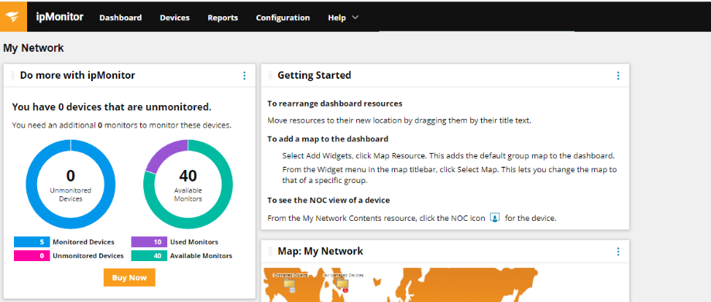

1. A picture containing text

   Description automatically generatedWe will now start a scan. Go back into Wireshark and start a new scan for SNMP only.
2. Go back into ipMonitor → Devices → Discovery → Express Scan.

1. You will select the default settings, default address ranges and default windows credentials as you setup the scan.

1. Once you click next on Windows credentials, the scan will start and you should see the following image.

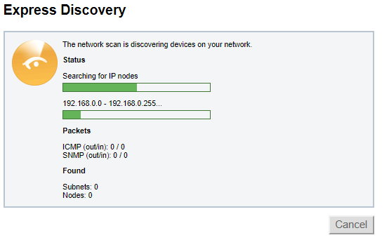

**Part 3: Wireshark Analysis**

1. When the scan is complete, Wireshark will display all the SNMP packets sent out during the scan.
2. ipMonitor sent out SNMP Get packets with a variable binding to look for an SNMP agent in the network.
3. Open one of the SNMP packets and look at the structure of the SNMP Get Packet.

What source and destination port were used?  
  
Source: 63063

Destination: 161

Why did the devices return “Destination Unreachable” ICMP Packets?  
  
It means this port is not open. The port I was getting destination unreachable was my Wi-Fi IP.